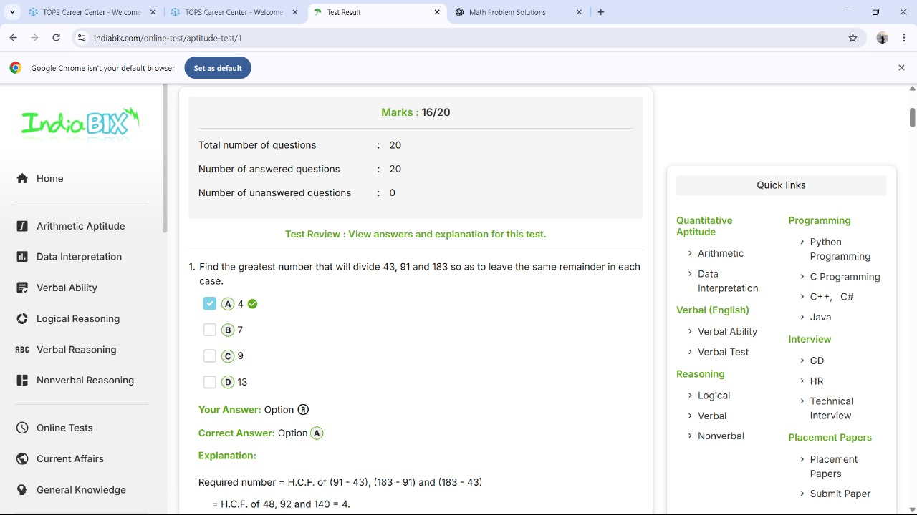



[2025-07-19 19.44.22 Mahek sukhvani's Zoom Meeting](https://1drv.ms/f/c/574ac9d36ffcc8ce/EhYjtmojYh5KozfN98r_j7MBqmZu8S3U4hnqZzVZLmQ4rA?e=zfUYqx)